

**SIX WEEKS SUMMER TRAINING REPORT**

On

**WEB DESIGN FOR EVERYBODY: BASICS OF WEB DEVELOPMENT AND CODING**

Submitted by:

**Name: Abhishek Agarwal**

**Registration No.:11904125**

**Programme: B.Tech CSE (Hons.)**

Under The Guidance of

**Colleen Van Lent (University of Michigan)**

**Coursera**

**School of Computer Science & Engineering**

**Lovely Professional University, Phagwara**

(June-July, 2021)

**DECLARATION**

I hereby declare that I have completed my six weeks summer training by Coursera through online mode from 28 May 2021 to 08 July 2021 under the guidance of Mam Colleen Van Lent (University of Michigan). I have declare that I have worked with full dedication during these six weeks of training and my learning outcomes fulfill the requirements of training for the award of degree of B.Tech CSE(Hons.), Lovely Professional University, Phagwara.

Date: 30 September 2021 Abhishek Agarwal

11904125

**ACKNOWLEDGEMENT**

I would like to express my special thanks of gratitude to Lovely Professional University who gave me a golden opportunity to do this summer internship and also faculties for proving support in completing my project.

I would also like to extend my gratitude to our Coursera Platform for providing me the specialization with all the facilities that were required.

Abhishek Agarwal

11904125

**CERTIFICATE**

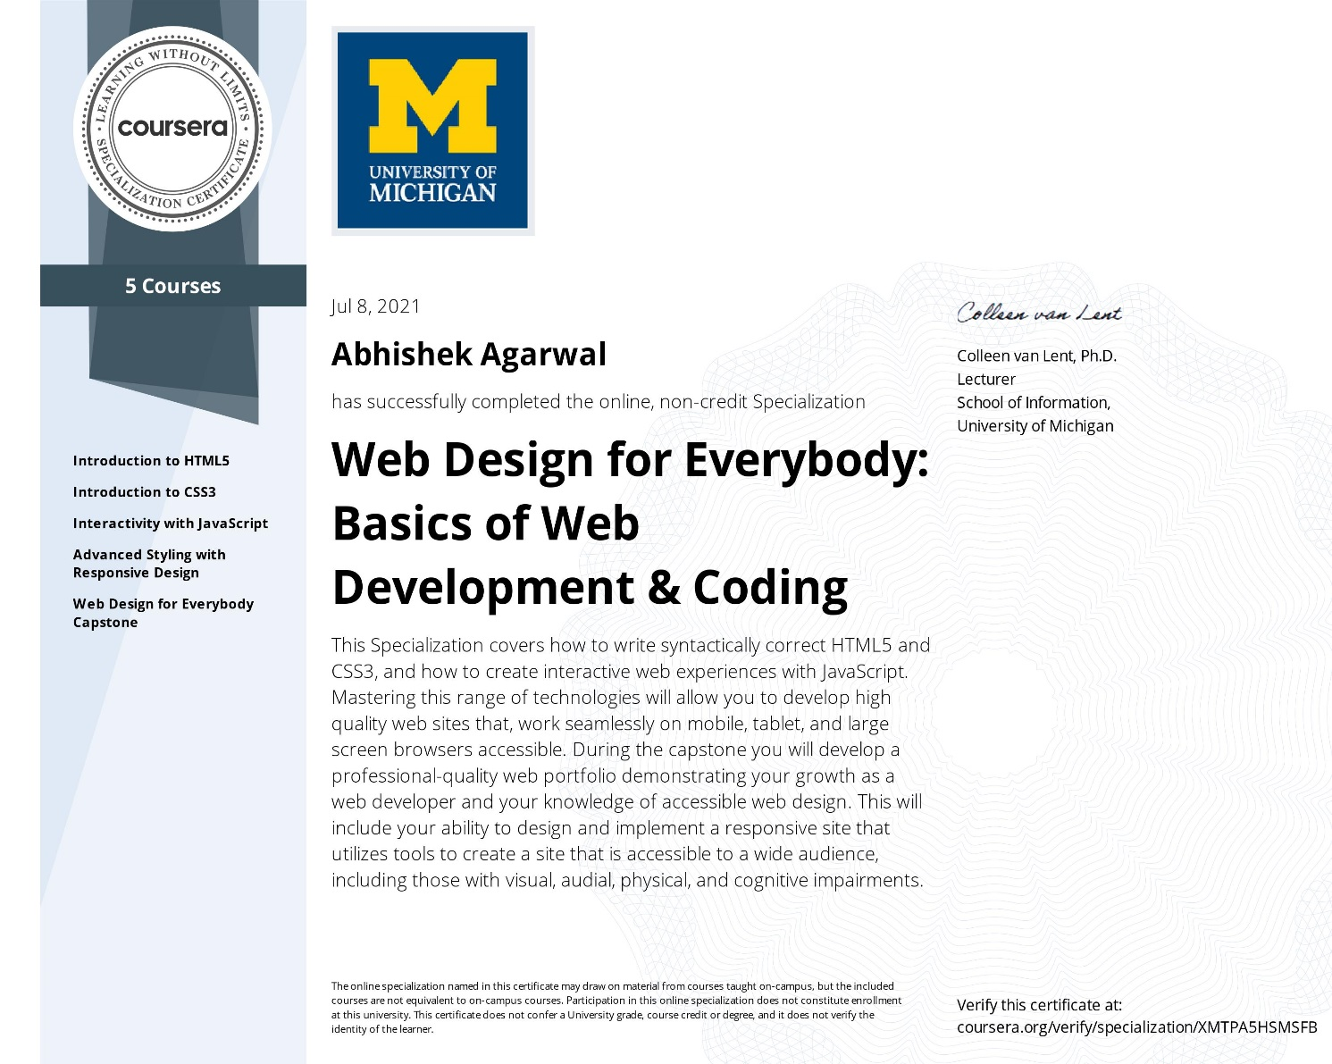

**INDEX**

**1. INTRODUCTION**

**2. FRONT-END WEB DEVELOPMENNT**

**3. Goals and challenges in front-end development**

**4. Tools used for front-end development**

* **HTML5**
* **CSS3**
* **JAVASCRIPT**

**5. PROJECT**

* **CAR RENTAL SYSTEM**

**6. CONCLUSION**

**INTRODUCTION**

Web development is the work involved in developing a Web site for the Internet (World Wide Web) or an intranet (a private network). Web development can range from developing a simple single static page of plain text to complex web applications, electronic businesses, and social network services. A more comprehensive list of tasks to which Web development commonly refers, may include Web engineering, Web design, Web content development, client liaison, client-side/server-side scripting, Web server and network security configuration, and e-commerce development.

Among Web professionals, "Web development" usually refers to the main non-design aspects of building Web sites: writing mark-up and coding. Web development may use content management systems (CMS) to make content changes easier and available with basic technical skills.

For larger organizations and businesses, Web development teams can consist of hundreds of people (Web developers) and follow standard methods like Agile methodologies while developing Web sites. Smaller organizations may only require a single permanent or contracting developer, or secondary assignment to related job positions such as a graphic designer or information systems technician. Web development may be a collaborative effort between departments rather than the domain of a designated department. There are three kinds of Web developer specialization: **front-end developer, back-end developer, and full-stack developer**. Front-end developers are responsible for behaviour and visuals that run in the user browser, while back-end developers deal with the servers.

**FRONT-END WEB DEVELOPMENNT**

Front-end web development, also called client-side development, refers to writing Hyper Text Mark-up Language (HTML), Cascading Style Sheets (CSS) and JavaScript code for a website or web application so that users can see and interact directly with them.

To delve further into this subject, it is important to know the basic differences between front-end development, back-end development and full stack development. Simply put, a front end developer works on the parts / aspects of an app or website that users get to see and interact with. Whereas a back-end developer handles the behind-the-scenes aspects of the said app or website, say the infrastructure and databases. On the other hand, a full-stack developer does both, so it’s someone who deals with the whole design process from start to finish.

The bottom line is this: there are some websites and web applications that only need front end development. For instance, a single page info website. However, anything functional generally needs back-end development. So all that you see on the page - and by that we are referring to anything happening on the user’s computer - is a result of front-end development. Anything that provides data from a server comes under back-end development. So when in use, an app’s front-end (the page) has requests sent to the back-end (i.e. server) which then sends across information in plain format. The front end then renders it with styling, whereas the backend is the code on the server, and its job is to communicate with the database.

**Goals and challenges in front-end development**

**The following are the main front-end development goals:**

**- Accessibility:** This is where they ensure that everyone - irrespective of their mobile device (think smartphones and tablets) - can easily access the said website or app. Basically, here front-end developers get their site to show up correctly in browsers on all devices. This is done with the help of a responsive web design using stylesheets in CSS.

**- Performance:** Performance here is measured in terms of the render time. So front-end developers work on the code to make sure that the site / app opens up quickly.

**- Speedy Development:** This is about a quick and smooth development process that is also high on efficiency.

The main challenge in front end development is that the tools and techniques used to build a website’s front end are subject to constant change. This means that a front-end developer needs to keep tabs on how the field is evolving, what are the latest tools and so on. Such a developer working on the site’s front-end has to come up with a format that makes it easy for the user to open and read relevant information on the said site. Moreover, with users accessing websites through different devices with varying screen sizes and resolutions, front-end developers have to deal with greater levels of complexity. Now they need to ensure that their site comes up correctly in different browsers, on different devices and on different operating systems (cross-platform).

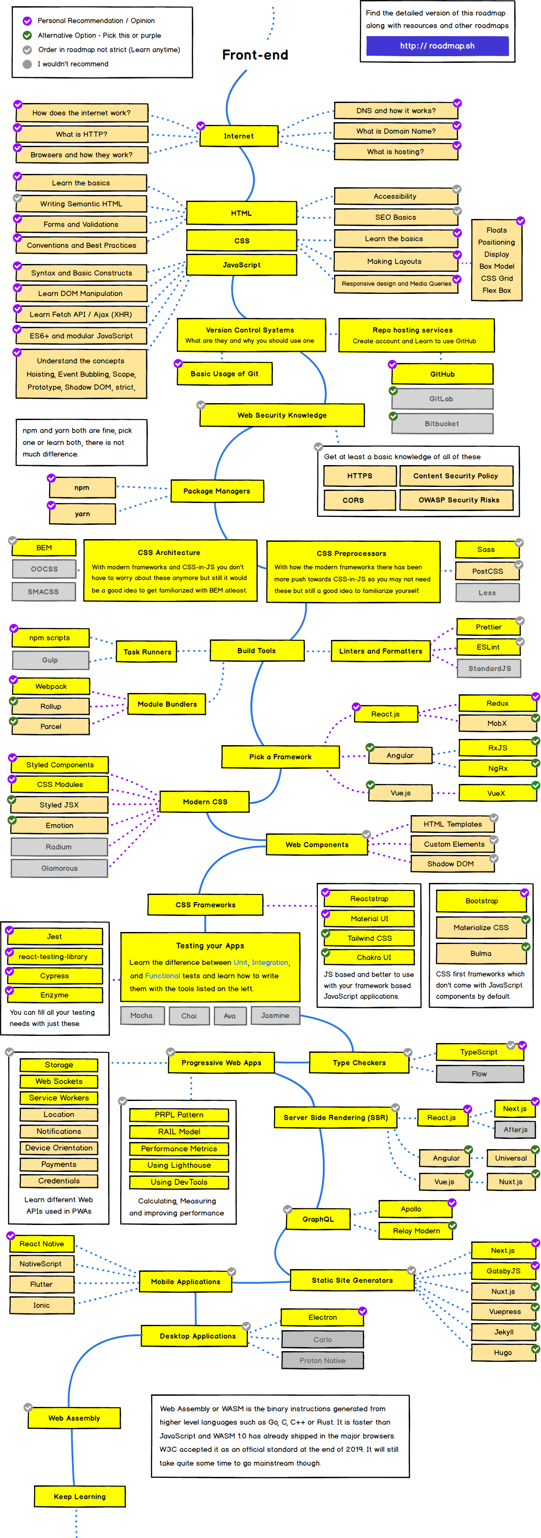

**Tools used for front-end development**

* **HTML5**

HTML stands for Hyper Text Mark-up Language. It is used to design web pages using mark-up language. HTML is the combination of Hypertext and Mark-up language. Hypertext defines the link between the web pages. Mark-up language is used to define the text document within tag which defines the structure of web pages. HTML 5 is the fifth and current version of HTML. It has improved the mark-up available for documents and has introduced application programming interfaces(API) and Document Object Model(DOM).

Features:

* It has introduced new multimedia features which supports audio and video controls by using <audio> and <video> tags.
* There are new graphics elements including vector graphics and tags.
* Enrich semantic content by including <header> <footer>, <article>, <section> and <figure> are added.
* Drag and Drop- The user can grab an object and drag it further dropping it on a new location.
* Geo-location services- It helps to locate the geographical location of a client.
* Web storage facility which provides web application methods to store data on web browser.
* Uses SQL database to store data offline.
* Allows to draw various shapes like triangle, rectangle, circle, etc.
* Capable of handling incorrect syntax.
* Easy DOCTYPE declaration i.e. <!doctype html>
* Easy character encoding i.e. <meta charset=”UTF-8″>

**Advantages:**

* All browsers supported.
* More device friendly.
* Easy to use and implement.
* HTML 5 in integration with CSS, JavaScript, etc. can help build beautiful websites.
* **CSS3**

CSS stands for Cascading Style Sheets. CSS is a standard style sheet language used for describing the presentation (i.e. the layout and formatting) of the web pages.

Prior to CSS, nearly all of the presentational attributes of HTML documents were contained within the HTML markup (specifically inside the HTML tags); all the font colors, background styles, element alignments, borders and sizes had to be explicitly described within the HTML.

As a result, development of the large websites became a long and expensive process, since the style information were repeatedly added to every single page of the website.

To solve this problem CSS was introduced in 1996 by the World Wide Web Consortium (W3C), which also maintains its standard. CSS was designed to enable the separation of presentation and content. Now web designers can move the formatting information of the web pages to a separate style sheet which results in considerably simpler HTML markup, and better maintainability.

And just like HTML even CSS has evolved over the years, the latest version being CSS3, the latest version has added a lot of new capabilities to existing ones.

CSS3 together with HTML5 has been at the forefront of advanced WebDesign and Web Development.

**Working of CSS**

1. For any WebDocument, the HTML defines the structure of the Webpage while the CSS defines the appearance and style of the Webpage.

2. The appearance of the entire document and every single element can be controlled to great detail with CSS. These properties can be weight, color, size, shadow etc.

3. You can set the CSS settings for specific HTML tags at one central location and it affects the appearance of these targeted elements.

4. Whenever you visit a webpage ,the webserver sends you the HTML file along with the CSS code for that file(internal or external).

5. The Web Browser interprets the file and then applies the CSS styles to the HTML elements usings its particular rendering engine.

* **JAVASCRIPT**

JavaScript (js) is a light-weight object-oriented programming language which is used by several websites for scripting the webpages. It is an interpreted, full-fledged programming language that enables dynamic interactivity on websites when applied to an HTML document. It was introduced in the year 1995 for adding programs to the webpages in the Netscape Navigator browser. Since then, it has been adopted by all other graphical web browsers. With JavaScript, users can build modern web applications to interact directly without reloading the page every time. The traditional website uses js to provide several forms of interactivity and simplicity.

Although, JavaScript has no connectivity with Java programming language. The name was suggested and provided in the times when Java was gaining popularity in the market. In addition to web browsers, databases such as CouchDB and MongoDB uses JavaScript as their scripting and query language.

## Features of JavaScript

There are following features of JavaScript:

1. All popular web browsers support JavaScript as they provide built-in execution environments.
2. JavaScript follows the syntax and structure of the C programming language. Thus, it is a structured programming language.
3. JavaScript is a weakly typed language, where certain types are implicitly cast (depending on the operation).
4. JavaScript is an object-oriented programming language that uses prototypes rather than using classes for inheritance.
5. It is a light-weighted and interpreted language.
6. It is a case-sensitive language.
7. JavaScript is supportable in several operating systems including, Windows, macOS, etc.
8. It provides good control to the users over the web browsers.

**PROJECT**

**CAR RENTAL SYSTEM**

CHAPTER-1

INTRODUCTION TO ONLINE CAR RENTAL SYSTEM

1.1 Introduction

This project is designed so as to be used by Car Rental Company specializing in renting

cars to customers. It is an online system through which customers can view available

cars, register, view profile and book car.

1.2 Reason for the Project

The advancement in Information Technology and internet penetration has greatly

enhanced various business processes and communication between companies (services

provider) and their customers of which car rental industry is not left out. This E-Car

Rental System is developed to provide the following services:

weddings or corporate meetings (Event management).

CHAPTER-1

INTRODUCTION TO ONLINE CAR RENTAL SYSTEM

1.1 Introduction

This project is designed so as to be used by Car Rental Company specializing in renting

cars to customers. It is an online system through which customers can view available

cars, register, view profile and book car.

1.2 Reason for the Project

The advancement in Information Technology and internet penetration has greatly

enhanced various business processes and communication between companies (services

provider) and their customers of which car rental industry is not left out. This E-Car

Rental System is developed to provide the following services:

weddings or corporate meetings (Event management).

**Introduction**

This project is designed so as to be used by Car Rental Company specializing in renting cars to customers. It is an online system through which customers can view available cars, register, view profile and book car.

**Reason for the Project**

The advancement in Information Technology and internet penetration has greatly

enhanced various business processes and communication between companies (services provider) and their customers of which car rental industry is not left out.

This E-Car Rental System is developed to provide the following services:

• Enhance Business Processes: To be able to use internet technology to project the

rental company to the global world instead of limiting their services to their local

domain alone, thus increase their return on investment (ROI).

• Online Vehicle Reservation: A tools through which customers can reserve available cars online prior to their expected pick-up date or time.

• Customer’s registration: A registration portal to hold customer’s details, monitor their transaction and used same to offer better and improve services to them.

• Group bookings: Allows the customer to book space for a group in the case of

weddings or corporate meetings (Event management)

**Problem Statement**

A car rental is a vehicle that can be used temporarily for a fee during a specified period.

Getting a rental car helps people get around despite the fact they do not have access to

their own personal vehicle or don't own a vehicle at all. The individual who needs a car

must contact a rental car company and contract out for a vehicle. This system increases

customer retention and simplify vehicle and staff management.

**Aims & Objectives**

• To produce a web-based system that allow customer to register and reserve car online

and for the company to effectively manage their car rental business.

• To ease customer’s task whenever they need to rent a car.

**Scope**

This project traverses a lot of areas ranging from business concept to computing field,

and required to perform several researches to be able to achieve the project objectives.

The area covers include:

• Car rental industry: This includes study on how the car rental business is being done,

process involved and opportunity that exist for improvement.

• PHP Technology used for the development of the application.

• General customers as well as the company’s staff will be able to use the system

effectively.

• Web-platform means that the system will be available for access 24/7 except when

there is a temporary server issue which is expected to be minimal.

**PROJECT WORK**

* **Home Page**

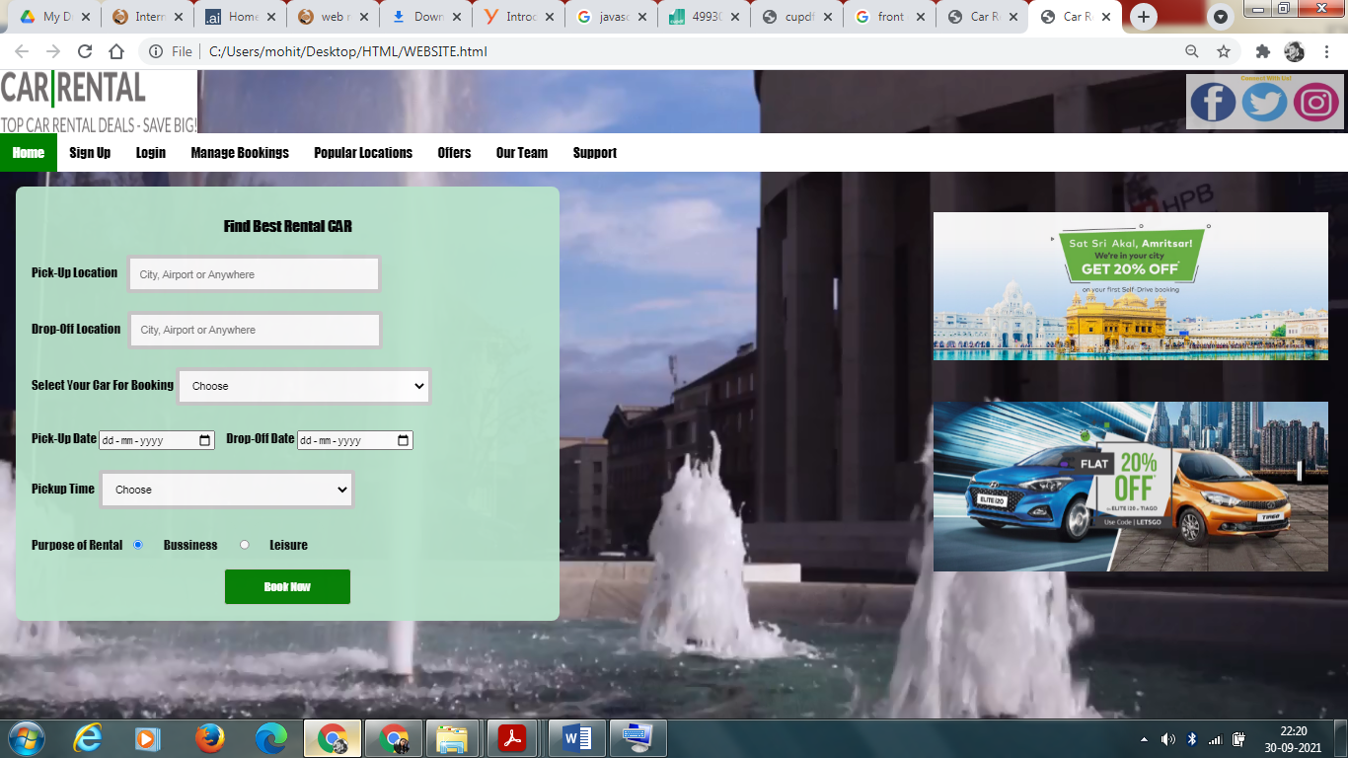

**SCRIPT OF HOME PAGE**

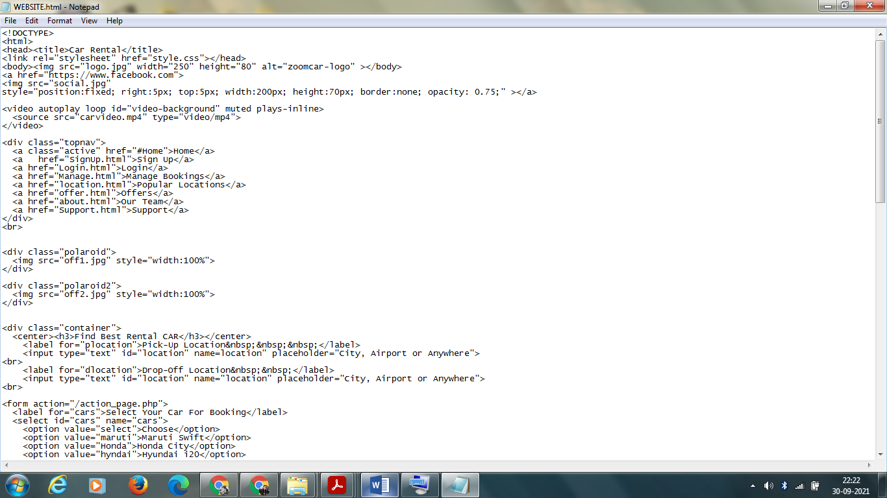

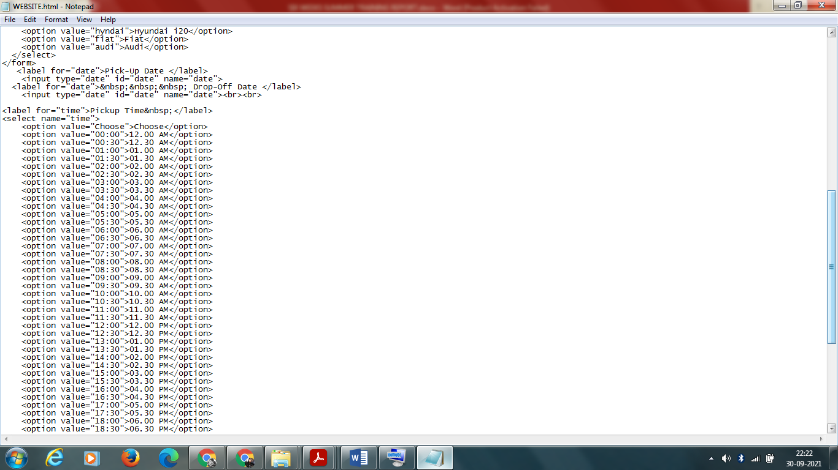

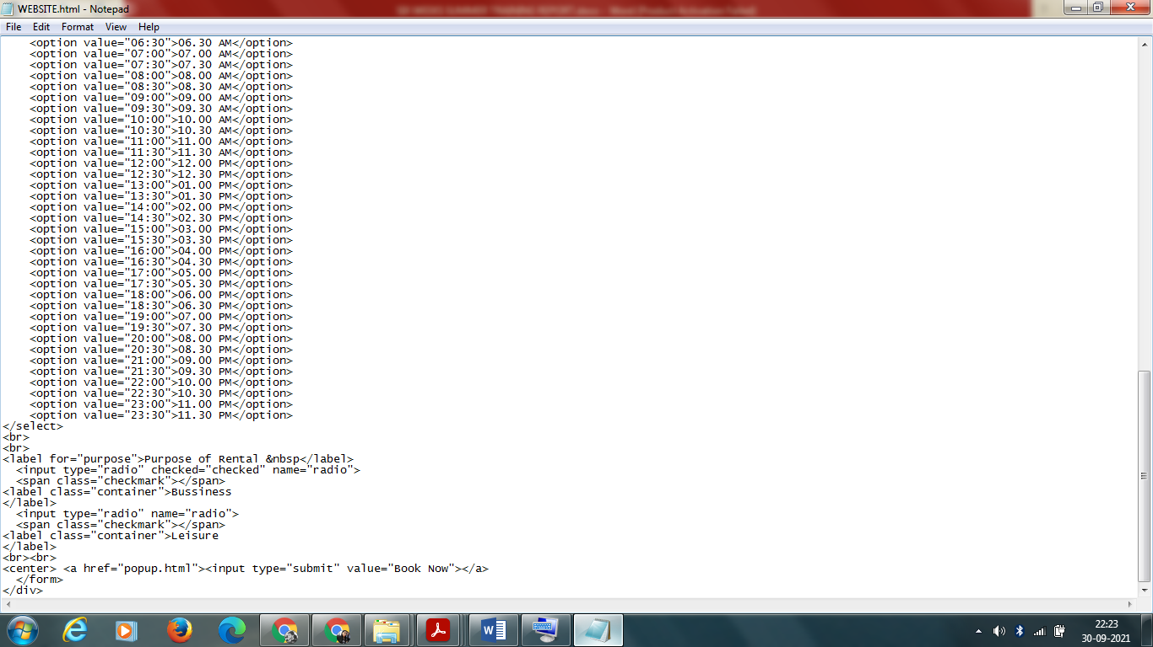

**Style.css**

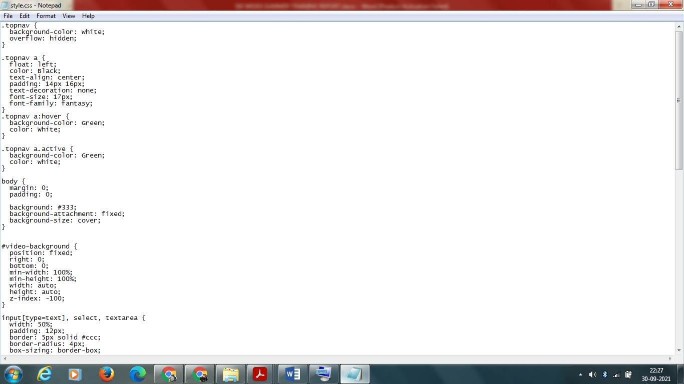

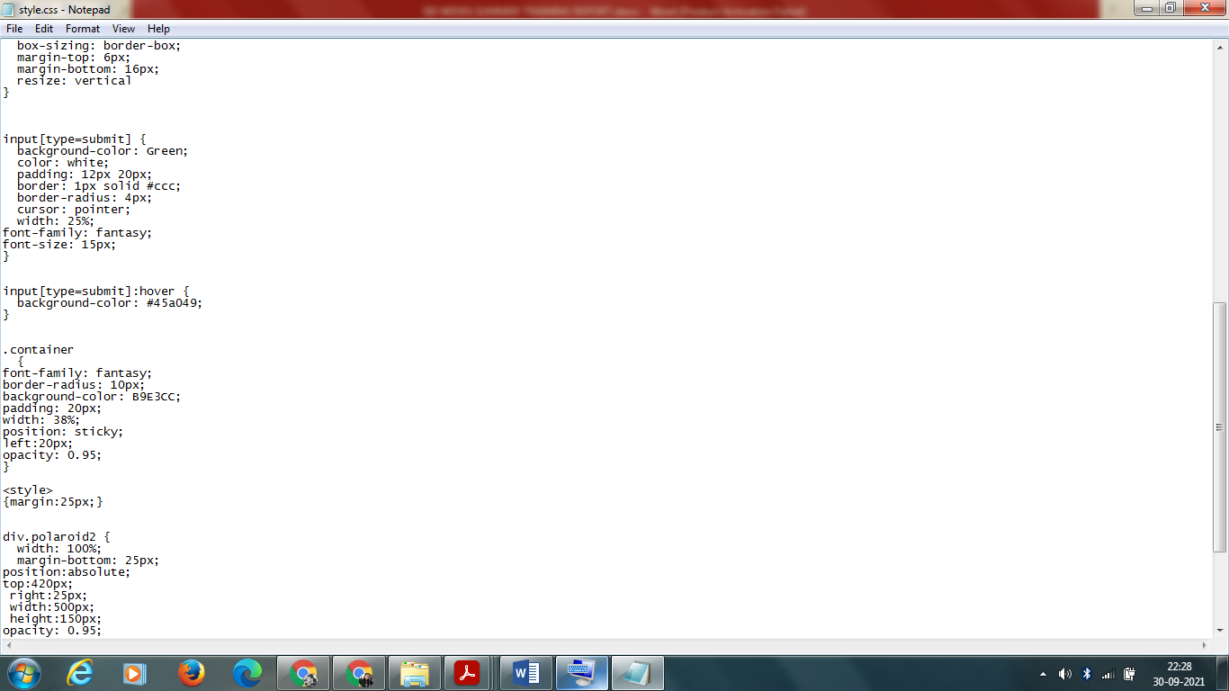

**SIGN UP PAGE**



**SCRIPT**

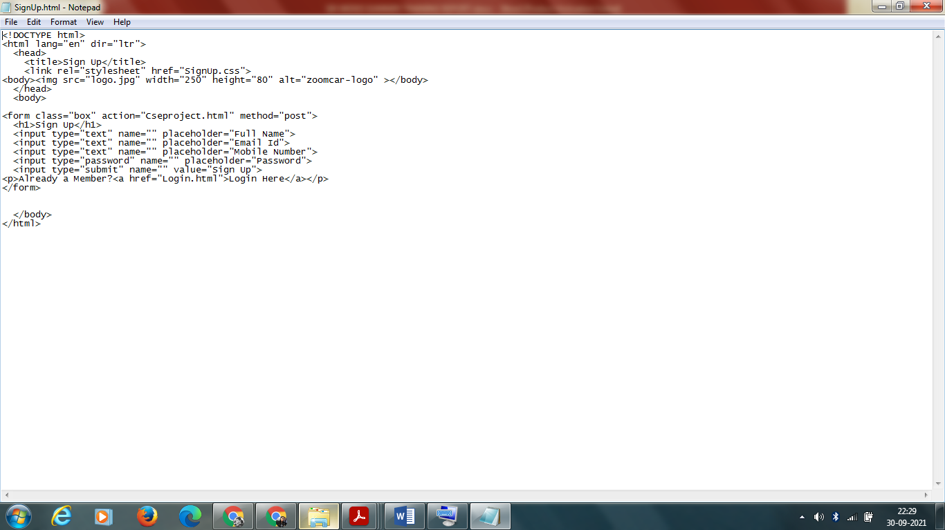

**Signup.css**

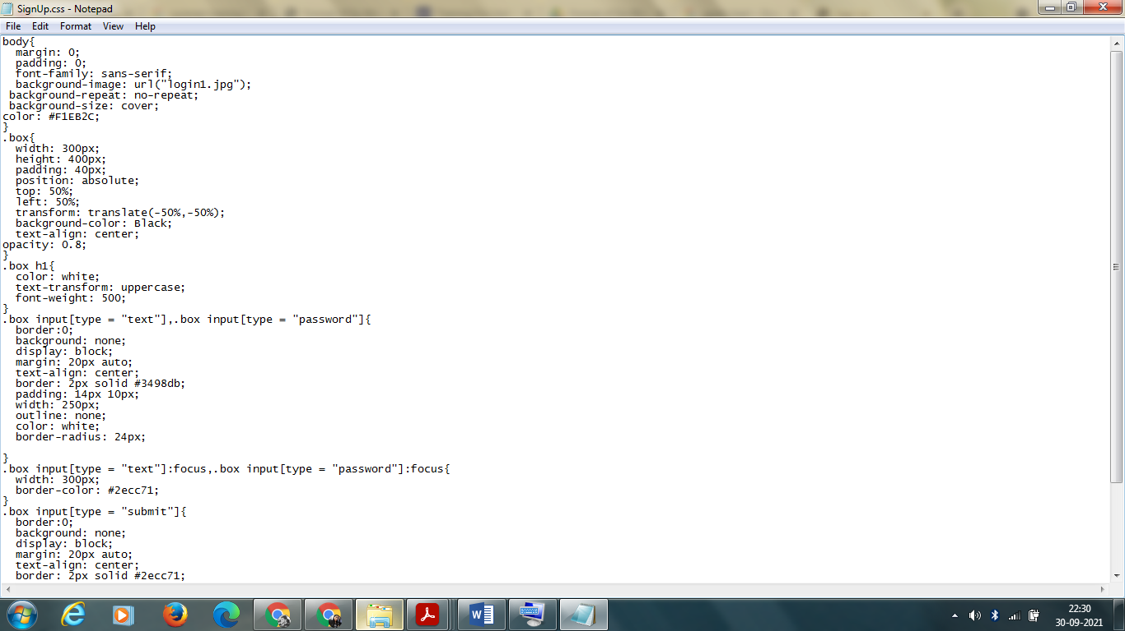

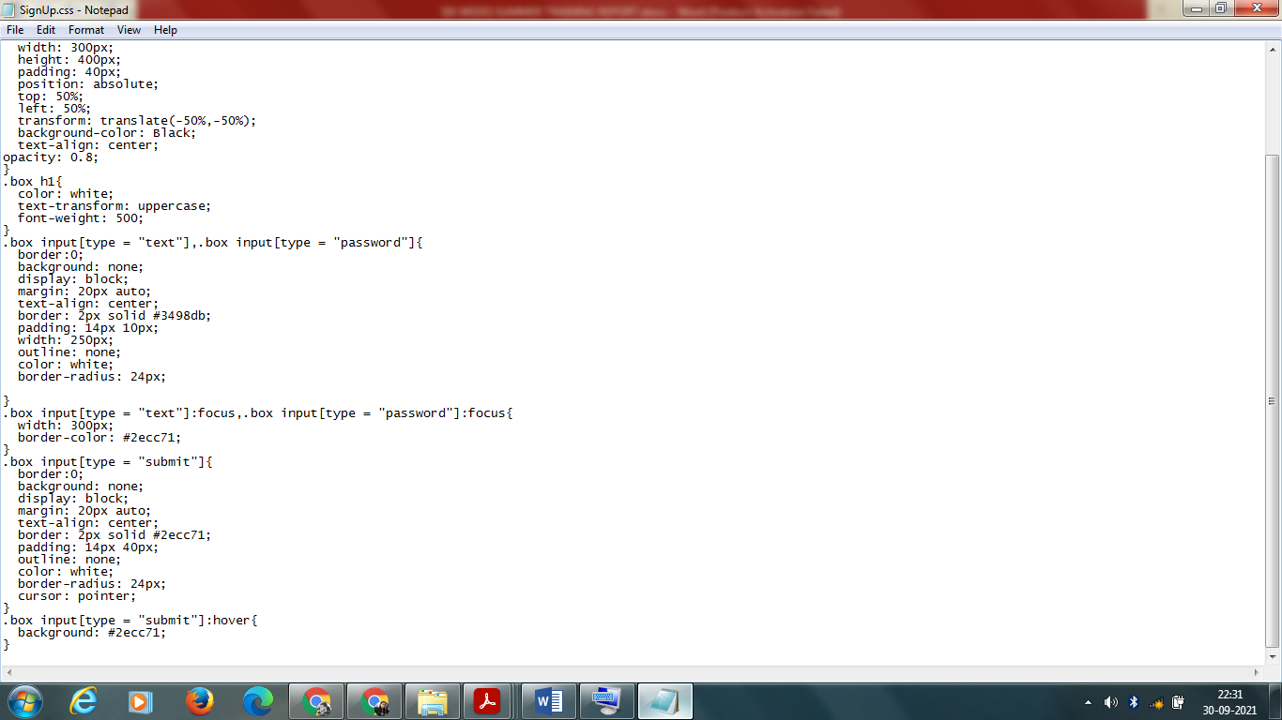

**MANAGE BOOKING PAGE**



**SCRIPT**

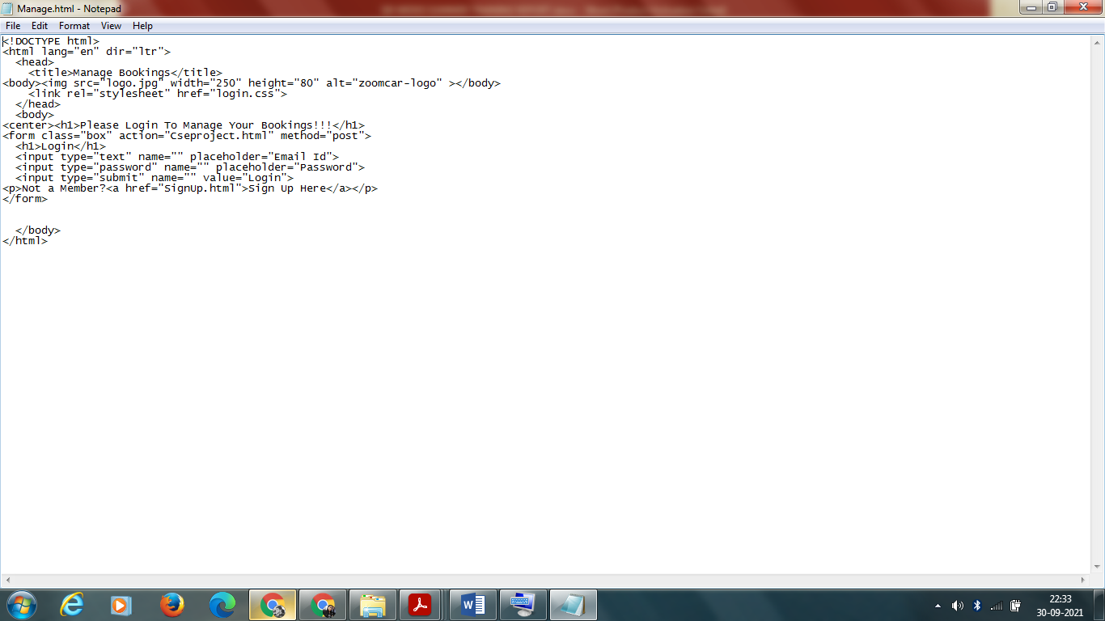

**POPULAR LOCATIONS**

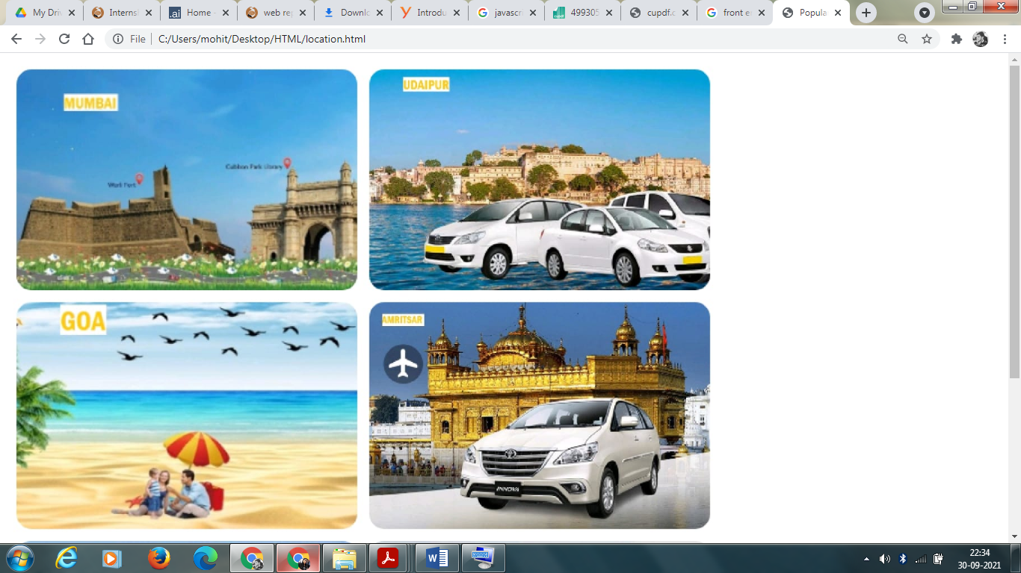

**SCRIPT**

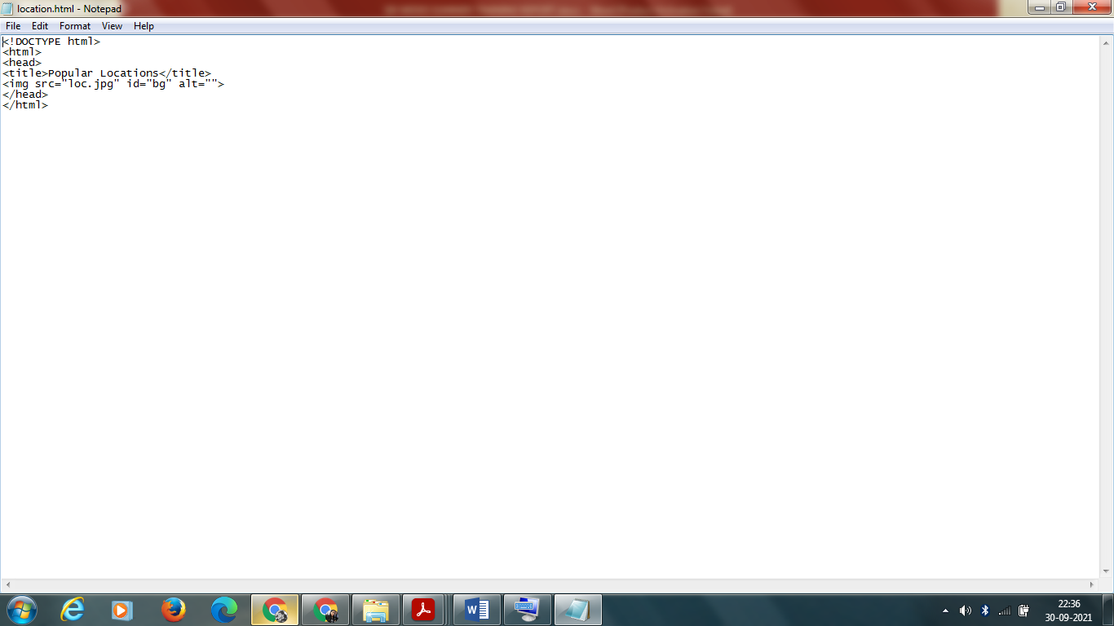

**OFFERS PAGE**



**SCRIPT**

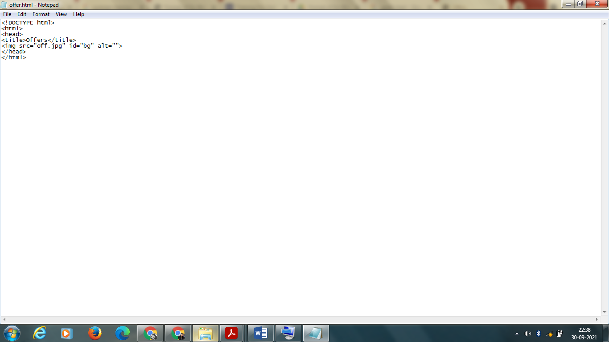

**Offer.css**



**ABOUT PAGE**

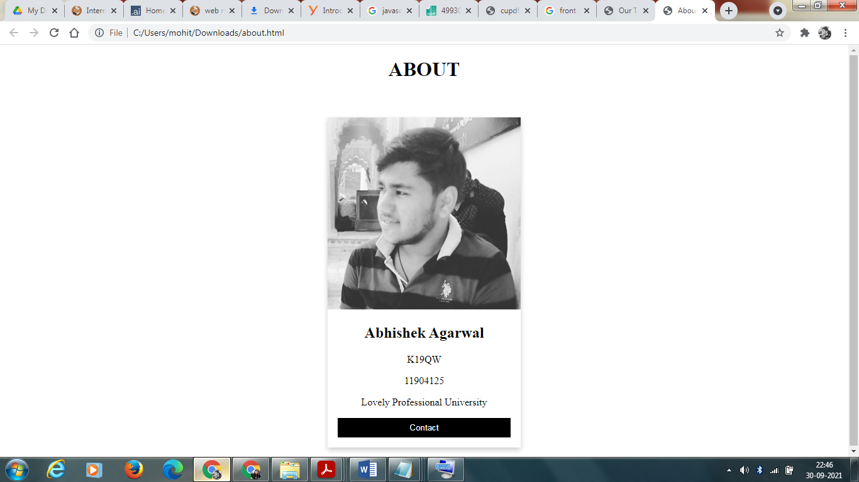

**SCRIPT**

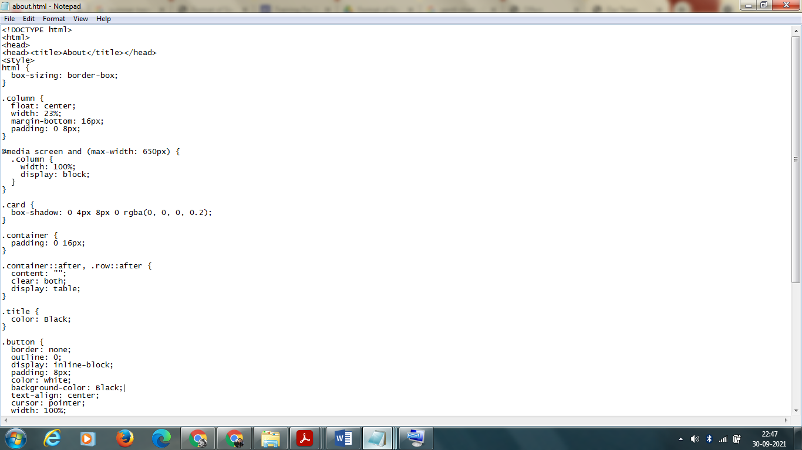

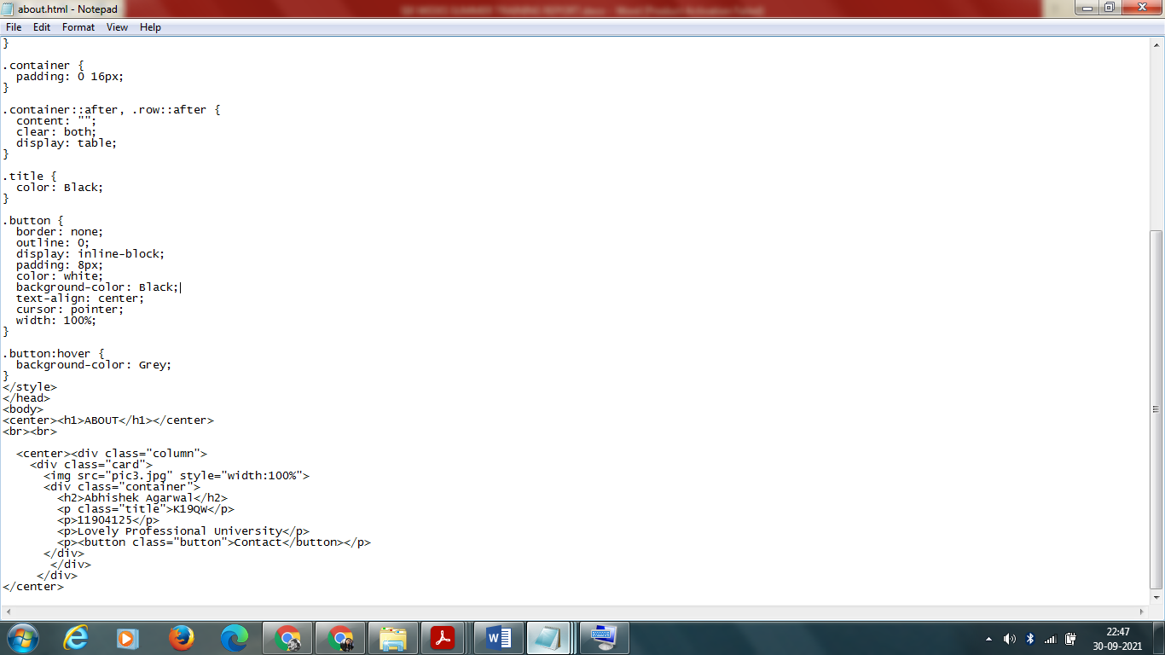

**SUPPORT PAGE**



**SCRIPT**

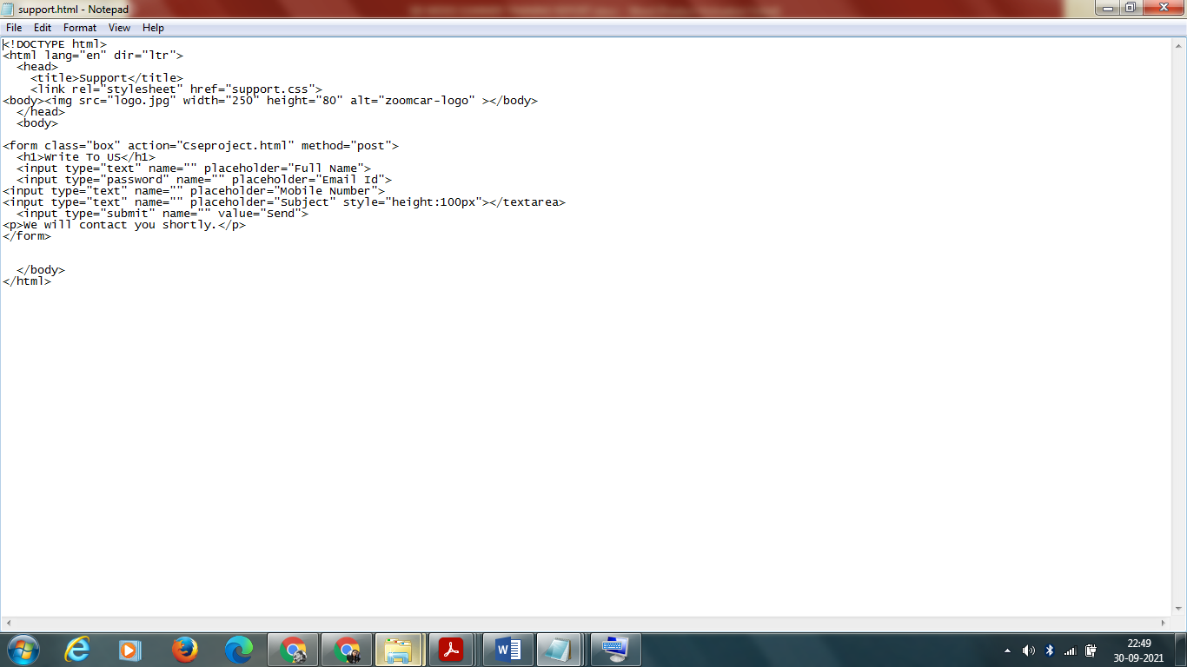

**Support.css**

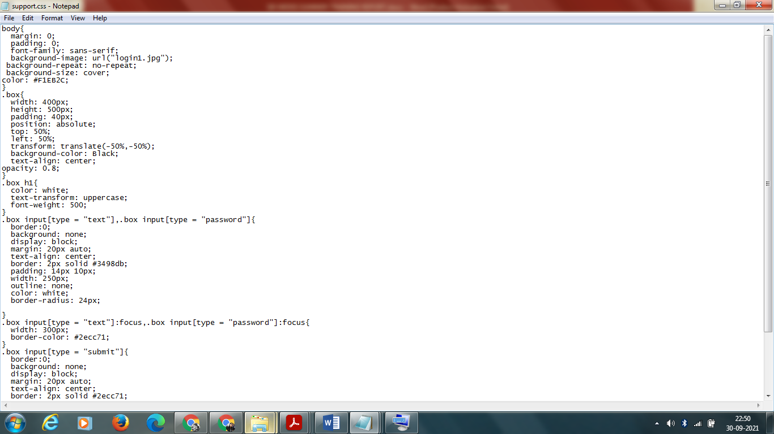

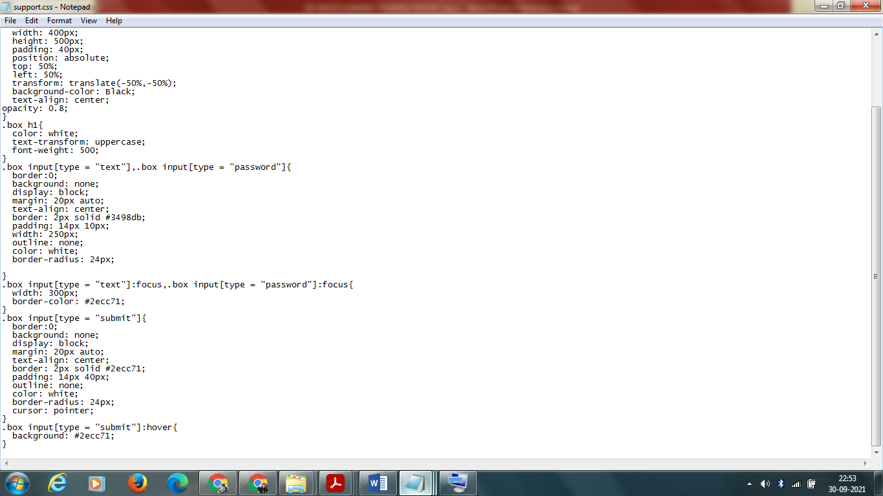

**CONCLUSION**

In a nutshell, this internship has been an excellent and rewarding experience. I can

conclude that there have been a lot I’ve learnt from this specialization.

Needless to say, the technical aspects of the work I’ve done are not flawless and

could be improved provided enough time.

As someone with no prior experience in JavaScript whatsoever I believe my time

spent in research and discovering new languages was well worth it and contributed

to finding an acceptable solution to an important aspect of web design and

development. Two main things that I’ve learned the importance of are

time-management skills and self-motivation. Although I have often stumbled upon

these problems at University, they had to be approached differently in a working

environment.

I have yet to complete another two years of studies, in order to achieve a bachelor

degree in Computing (with Honours). Working with web development languages

has increased my interest in them, hence prompting me to transfer to the Web

Design and Development course at my university.